**Sprint** 3 **-** Agility **Design Document**

December 7th 2022

**Table of Contents**

**1.** **EXECUTIVE SUMMARY 3**

1.1 Project Overview 3

1.2 Purpose and Scope of this Specification 3

**2.** **PRODUCT/SERVICE DESCRIPTION 3**

2.1 Product Context 3

2.2 User Characteristics 3

2.3 Assumptions 3

2.4 Constraints 3

2.5 Dependencies 4

**3.** **REQUIREMENTS 4**

3.1 Functional Requirements 5

3.2 Security 5

*3.2.1* *Protection 5*

*3.2.2* *Authorization and Authentication 6*

3.3 Portability 6

**4.** **REQUIREMENTS CONFIRMATION/STAKEHOLDER SIGN-OFF 6**

**5.** **SYSTEM DESIGN 6**

5.1 Algorithm 6

5.2 System Flow 6

5.3 Software 6

5.4 Hardware 6

5.5 Test Plan 7

5.6 Task List/Gantt Chart 7

5.7 Staffing Plan 7

# Executive Summary

## ***Project Overview***

The Sprint 3 Agility Project is designed to help the Sphero SPRK+ navigate an obstacle course without colliding with any obstacles. It must turn effectively three times without colliding with a bottle, go over the ramp, turn and knock down the group of markers. This is part 3 of 3 in the Robotics Triathlon.

## ***Purpose and Scope of this Specification***

**In scope**

This document addresses requirements related to part 2 of the Robotics Triathlon:

● Agility of the robot to navigate the obstacle course without hitting obstacles, and the robot must hit down pins on a predefined path

**Out of Scope**

The following items in part 1 and 3 of the Robotics Triathlon Project are out of scope and documented separately:

1. Measurements of lengths and angles of the path the robot has to navigate.
2. Light Colors and required speech of the robot.
3. Accuracy of the robot to go around figure 8 shape five times.

# Product/Service Description

## ***Product Context***

* This project uses the Sphero app on Apple devices like the Macbook and iPhone to test the Sphero SPRK+ robot to perform certain tasks.

## ***User Characteristics***

* Our group consists of Dylan, Gideon, and Peter who are learning computer science and software engineering principles.

## ***Assumptions***

* We are assuming the robot does not have any hardware issues and is capable of executing our instructions effectively.

## ***Constraints***

* Access to HH Room 208
* The robot can not collide with any objects
* The robot must remain on course

## ***Dependencies***

* A working robot
* Sphero Edu program must be compatible with our devices
* Room with a floor plan for the robot to navigate

# Requirements

1. Robot must be functional and ready to be programmed
2. Sphero software is ready for use
3. Algorithm is layed out in preparation for completion of the flowchart
4. Flowchart upon completion should be ready to be formatted into block code
5. Block code then runs robot/robot runs course
6. Gantt chart is filled out further
7. Github repository marks progression

## ***Functional Requirements***

| **Req#** | **Requirement** | **Comments** | **Priority** | **Date Rvwd** | **SME Reviewed / Approved** |
| --- | --- | --- | --- | --- | --- |
| AGILITY01 | Start in square |  | 1 | 12/7/22 | Dylan/Gideon |
| AGILITY_02 | Roll 0° at 65 speed for 1.5 seconds |  | 1 | 12/7/22 | Dylan/Gideon |
| AGILITY_03 | Delay for 2 seconds |  | 1 | 12/7/22 | Dylan/Gideon |
| AGILITY_04 | Roll 91° at 42 speed for 2.65 seconds |  | 1 | 12/7/22 | Dylan/Gideon |
| AGILITY_05 | Delay for 2 seconds |  | 1 | 12/7/22 | Dylan/Gideon |
| AGILITY_06 | Roll 357° at 42 speed for 3 seconds |  | 1 | 12/7/22 | Dylan/Gideon |
| AGILITY_07 | Delay for 2 seconds |  | 1 | 12/7/22 | Dylan/Gideon |
| AGILITY_08 | Roll 90° at 233 speed for 1.5 seconds |  | 1 | 12/7/22 | Dylan/Gideon |
| AGILITY_09 | Stop |  | 1 | 12/7/22 | Dylan/Gideon |
| AGILITY_10 | Delay for 3 seconds |  | 1 | 12/7/22 | Dylan/Gideon |
| AGILITY_11 | Roll 223° at 210 speed for 3.4 seconds |  | 1 | 12/7/22 | Dylan/Gideon |

## ***Security***

### **Protection**

* Sphero prompts a user login every time the app is accessed

### **Authorization and Authentication**

* Users creates their own Login id and password to the Sphero app

## ***Portability***

* All files sent to Github Repository: <https://github.com/GideonQ/Agility>

Include documentation of the approval or confirmation of the requirements here. For example:

| **Meeting Date** | **Attendees (name and role)** | **Comments** |
| --- | --- | --- |
| 12/7/22 | Gideon Quaye (Software Design), Dylan Welsh (System Design) | Finished code and system design |
| 12/9/22 | Gideon Quaye (Software Design), Dylan Welsh (System Design) | Video taped robot |

# System Design

This section will provide all details concerning the technical design, staffing, coding, and testing the system

## ***Algorithm***

Develop and describe here the algorithm that will be used to provide the required performance of your software

1. Start
2. Roll 0° at 65 speed for 1.5 seconds
3. Delay for 2 seconds
4. Roll 91° at 42 speed for 2.65 seconds
5. Delay for 2 seconds
6. Roll 357° at 42 speed for 3 seconds
7. Delay for 2 seconds
8. Roll for 90° at 223 speed for 1.5 seconds
9. Stop
10. Delay for 3 seconds
11. Exit Program

***5.2 System Flow***

Develop a flowchart (and show here) that accurately depicts how your software application will act to fulfill the algorithm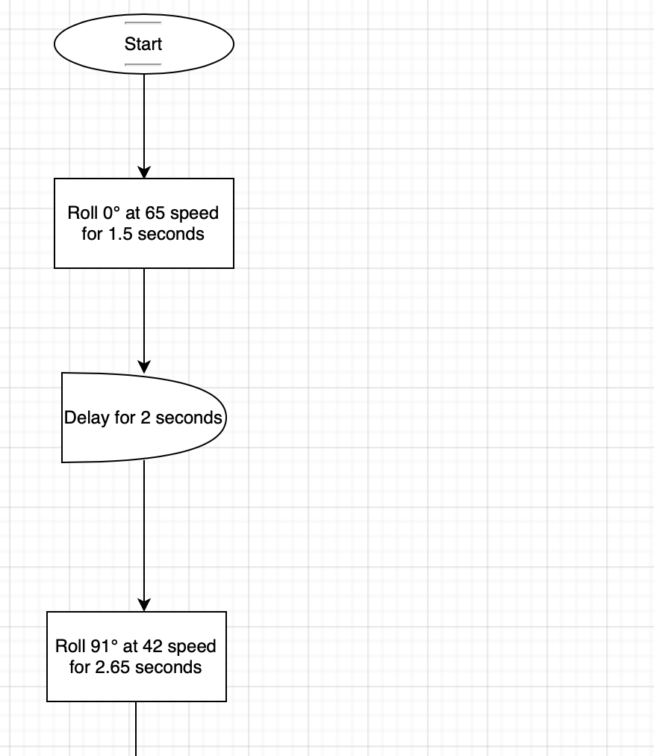

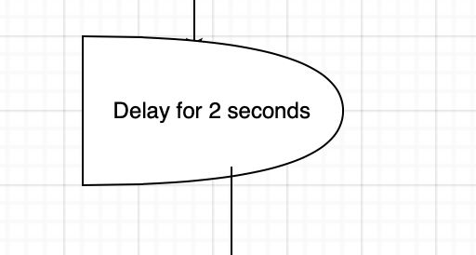

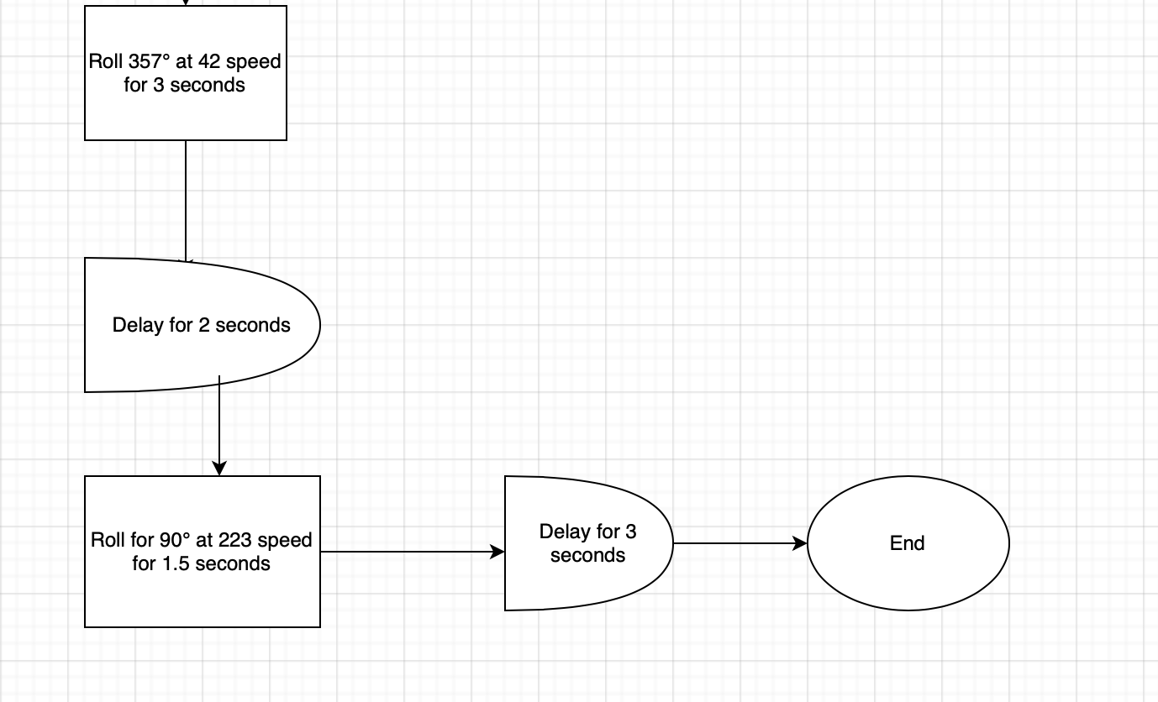

## ***Software***

Describe software languages/platforms/api’s used to develop and deploy this application

* Sphero Edu

## ***Hardware***

Describe hardware platforms that were used to develop, test and demonstrate this application

* MacBook Pro with macOS Big Sur 11.7 + Sphero Robot SPRK+

## ***Test Plan***

Include a test plan showing all unit tests performed for this application, Include test rational, test date, staff member, pass/fail status

| **Reason for Test Case** | **Test Date** | **Expected Output** | **Observed Output** | **Staff Name** | **Pass/Fail** |
| --- | --- | --- | --- | --- | --- |
| To see if the robot moves far enough not to hit a bottle. | Dec 7 | The robot should make the first turn without colliding with the bottle. | The robot collided with the bottle. | Dylan/Gideon | Fail |
| To see if the robot moves far enough to avoid hitting a bottle. | Dec 7 | The robot should move far enough not to hit any bottles. | The robot was eventually able to complete the course without collision. | Dylan/Gideon | Pass |
| The robot needs to be in a location where it is able to ascend the ramp. | Dec 7 | The robot should ascend the ramp with ease. | The robot missed the ramp, a few times. | Dylan/Gideon | Fail |
| The robot missed the markers a few times, so a few parameters surrounding that block of code were changed. | Dec 9 | The robot is expected to knock down all of the markers. | The robot knocked down all of the markers. | Dylan/Gideon | Pass |

## ***Task List/Gantt Chart***

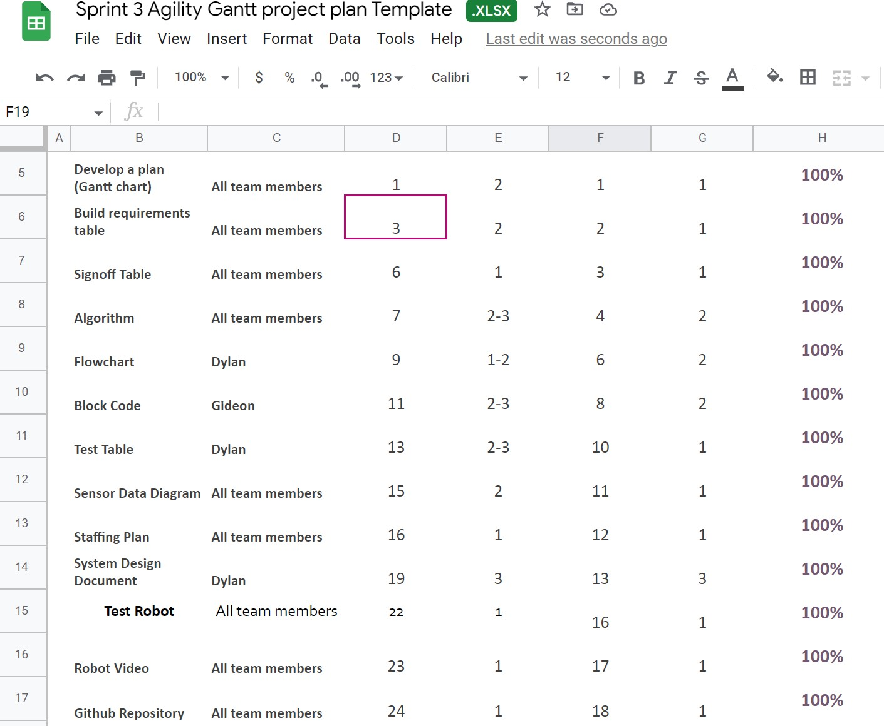

## ***Staffing Pla***n

Insert a chart/table that depicts the roles and responsibilities of each team member that worked on this project

| Name | Role | Responsibility | Reports To |
| --- | --- | --- | --- |
| Dylan | Project Manager, System Design | Suggests changes that should be made to better the procedure. Completes system design document, flowchart and Gantt chart. | Professor Eckert |
| Gideon | Project Manager, Software Design | Creates and tests the code. Suggests changes that should be made. Make sure the robot correctly follows procedure. | Professor Eckert |